**Vidush Somany Institute of Technology and Research, Kadi**

**A Project Report on**

**“Face Recognition System “**

**Submitted To**

**Kadi Sarva Vishwavidyalaya University**

**In Partial fulfilment towards the**

**award of degree**

**IN**

**Information Technology & Computer Engineering**

**October/November-2022**

**BY**

**Jogendra 19BEIT54018**

**Mohammed Vohra 19BECE54038**

***Certificate***

This is to certify that Mr. /Ms._**Jogendra**_from **Vidush Somany Institute of Technology & Research, Kadi** college having Enrollment No: **19BEIT54018** branch**:Information Technology** semester: **7th** has completed partial completed project on **“ Face Recognition“**.

**Institute Guide Head of Department**

Prof. Amit Modi Prof. Vimal Bhatt

**Assistant Professor Assistant Professor**

**VSITR, KADI VSITR, KADI**

***Certificate***

This is to certify that Mr. /Ms._**Mohhmed Vohra**_from **Vidush Somany Institute of Technology & Research, Kadi** college having Enrollment No: **19BECE54038** branch**:Computer Engineering** semester: **7th** has completed partial completed project on **“ Face Recognition“**.

**Institute Guide Head of Department**

Prof. Amit Modi Prof. Vimal Bhatt

**Assistant Professor Assistant Professor**

**VSITR, KADI VSITR, KADI**

**Project Profile**

|  |  |
| --- | --- |
| **Project Title:** | Face Recognition |
| **Goal of System:** | The main goal of our system is to provide automatic attendance System. |
| **Project Duration:** | One Semester |
| **Team Size:** | Two Student |
| **Internal Project Guide:** | Prof. Amit Modi |
| **Front End Tool:** | Python, Opencv |
| **Back End Tool:** | Opencv, Dlib, Numpy, face-Recognition Library |

**ACKNOWLEDGEMENT**

With immense pleasure I would like to present this report on my topic “Library Management System.” We thankful to all that have helped us a lot for successful completion of our project and providing us encourage for completing the work.

We are thankful to our Principle Mr. Hiren Patel Sir for his valuable guidance. We also express our gratitude to our Head of the Department **Prof. Vimal Bhatt** and my internal faculty guide **Prof. Amit Modi**, for providing guidance throughout my work giving us their valuable time.

At last, we would like to thank my parents and friends who have directly or indirectly helped me in making the project work successfully.

**Jogendra 19BEIT54018**

**Mohammed Vohra 19BECE54038**

**ABSTRACT**

Face recognition technology is a biometric technology, which is based on the identification of facial features of a person. People collect the face images, and the recognition equipment automatically processes the images. Face recognition has become the future development direction and has many potential application prospects

Uses

* Face recognition systems can be used to identify people in photos, videos.
* Attendance Tracking and Control

**Table of Contents:**

**Abstracts……………………………………………………….**

1. Introduction………………………………………………………...
   1. Background Introduction
   2. Current Systems
   3. Drawbacks in existing system
   4. Using Biometrics
   5. Motivation
2. Review of Literature…………………………………..................
3. Proposed Solution …………………..……………………………
   1. Proposed System Components
   2. Proposed System Outcome
   3. What contribution would the project make?
4. Aim And Objective………….……………………………………..
5. Problem Statement ……………………………………………....
6. Method And Materials…………………………………………….
   1. Tools and Technologies
   2. Mythology
7. Advantage …………………………………………………………
8. Disadvantage……………………………………………………...
9. Project Life Cycle………………………………………………….
10. System Requirements Specification………………………….
11. Application………………………………………………………
12. Project Challenges……………………………………………..
13. Diagram
14. System Screenshot and Explanation………………………...

**LIST OF FIGURES**

|  |  |  |
| --- | --- | --- |
| **NO** | **NAME** | **PAGE NO** |
| A | Function Diagram | 20 |
| B | Activity diagram | 21 |
| C | Class Diagram | 22 |
| D | Sequence Diagram | 23 |

**1.0 Introduction**

**1.1 Background Introduction**

The current method that institutions uses is the faculty passes an attendance sheet or make roll calls and mark the attendance of the students, which sometimes disturbs the discipline of the class and this sheet further goes to the admin department, which is then updated to an excel sheet. This process is quite hectic and time-consuming. Also, for professors or employees at institutes or organizations, the biometric system serves one at a time. So, why not shift to an automated attendance system which works on face recognition technique? Be it a classroom or entry gates it will mark the attendance of the students, professors, employees, etc.

**1.2 Current Systems**

At present, attendance, marking involves manual attendance on the paper sheet by professors and teachers, but it is a very time-consuming process and chances of proxy are also an issue that arises in such type of attendance marking. Also, there is an attendance marking system such as RFID (Radio Frequency Identification), Biometrics etc. But these systems are currently not that popular in schools and classrooms for students.

**1.3 Drawbacks in existing system**

Manual systems put pressure on people to be correct in all details of their work at all times, the problem being that people aren't perfect, however, each of us wishes we were.

* These attendance systems are manual.
* There is always a chance of forgery (one person signing the presence of the other one) Since these are manually so there is a great risk of error.
* More manpower is required.
* Calculations related to attendance are done manually (total classes attended in a month) which is prone to error.
* It is difficult to maintain a database or register in manual systems.
* It is difficult to search for a particular data from this system (especially if that data, we are asking for, is of very long ago).
* The ability to compute the attendance percentage becomes a major task as manual computation produces errors, and also wastes a lot of time.
* This method could easily allow for impersonation and the attendance sheet could be stolen or lost.

**1.4 Using Biometrics**

Biometric Identification Systems are widely used for unique identification of humans mainly for verification and identification. Biometrics is used as a form of identity access management and access control. So the use of biometrics in the student attendance management system is a secure approach. There are many types of biometric systems like fingerprint recognition, face recognition, voice recognition, iris recognition, palm recognition etc. In this project, we have used face recognition system.

**1.5 Motivation**

The main motivation for this project was the slow and inefficient traditional manual attendance system. So, why not make it automated fast and much efficiently. Also, such face detection techniques are in use by the department of a criminal investigation where the usage of CCTV footages and detecting the faces from the crime scene and comparing them with criminal database to recognize them. It is also becoming as a feature of daily life in China, where authorities are using it on the streets, in subway stations, and at airports.

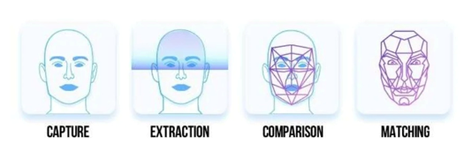

**2.0 Review of the Literature**

Face recognition is such a challenging yet interesting problem that it has attracted researchers from different backgrounds. It is due to this fact that the literature on face recognition is vast and diverse. The earliest work on face recognition can be traced back at least to the 1950s additionally; the research on automatic machine recognition of faces really started in the 1970s, but a fully automatic face recognition system based on a neural network was reported back in 1997.

The aim of all the researches was to make face recognition as automated and accurate as possible through various types of inputs such as static images, video clips, etc. so as to increase its applications in real world. Computational methods of face recognition need to address numerous challenges. These type of difficulties appear because faces are need to be represented in such a way that best utilizes the available face information to define a specific face from all the other faces in the database. Also, extracting such detailed facial features can be used in slandering the search and enhancing recognition.

The problem of automatic face recognition involves three key steps:

(1) Face Detection

(2) Recognition

(3) Feature extraction

Face recognition is one of the few biometric methods that possess the merits of both high accuracy and low intrusiveness. It has the accuracy of a physiological approach without being intrusive. Over past 30 years, many researchers have proposed different face recognition techniques, motivated by the increased number of real world applications requiring the recognition of human faces. There are several problems that make automatic face recognition a very difficult task. However, the face image of a person inputs to the database that is usually acquired under different conditions. The important of automatic face recognition is much be cope with numerous variations of images of the same face due to changes in the following parameters such as :

1. Pose

2. Illumination

3. Expression

4. Motion

5. Facial hair

6. Glasses

7. Background

**3.0 Proposed Solution**

To overcome the problems in the existing attendance system we shall develop a Biometric based attendance system over simple attendance system. There are many solutions to automate the attendance management system like thumbbased system, simple computerized attendance system, Iris scanner, but all these systems have limitations overwork and security point of view. Our proposed system shall be a "Face Recognition Attendance System" which uses the basic idea of image processing which is used in many security applications like banks, airports, Intelligence agencies etc.

**3.1 Proposed System Components**

Following are the main components of the proposed system

1. Student Registration

2. Face Detection

3. Face Recognition

- Feature Extraction

- Feature Classification

4. Attendance management system.

Attendance management will handle:

- Automated Attendance marking

- Manual Attendance marking

- Attendance details of users

- Email notification for absentees.

**﻿ 3.2 Proposed System Outcome**

It will mark attendance of the students via face Id. It will detect the faces via wireless camera (IP camera)/webcam and then recognize the faces. After recognition, it will mark the attendance of the recognized student and update the attendance record. The admin will be able to print these record details afterward. - The students will also receive an email on low attendance rate.

**3.3 What contribution would the project make?**

Face recognition is the most natural biological features recognition technology, according to the cognitive rule of human beings; its algorithm is ten times more complex than a fingerprint algorithm. The system will do its work even if one is not in touch with it or forget about it.

Face recognition is featured by the following advantages compared to fingerprint:

1. Accurate and Fast Identification

Industrial Leading Facial Recognition Algorithm, matches more data than a fingerprint, FAR<0.0001%.

2. High Usability and Security

Failure to enrol and acquire rate is less than 0.0001%, fingerprint technology will have problems for enrolment with cold, wet, desquamation, elder, and around 5% people cannot get enrolled with a photo which is captured by the camera, there is no evidence with fingerprint technology to track the incident.

3. User friendly design Contactless authentication for ultimate hygiene.

**4.0 Aim and Objective**

The objective of this project is to develop face recognition based automated student

attendance system. Expected achievements in order to fulfill the objectives are:

• To detect the face segment from the video frame.

• To extract the useful features from the face detected.

• To classify the features in order to recognize the face detected.

• To record the attendance of the identified student**.**

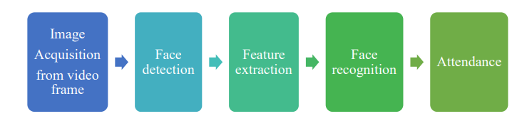

Figure 1.1 Block Diagram of the General Framework

**5.0 Problem Statement**

Face recognition attendance system used to mark the attendance details of students. It can mark the time of lecture and daily presence of the individuals in a premise and generate detailed reports on the same at regular intervals.

Technically following is the usefulness of this project:

1.Enhances security and speed in tracing student attendance and lecture time.

2.Easy to set up and use.

3.Convenient and inexpensive.

4.Helps in managing the time and attendance profiles of students.

5.Eliminates proxy punching.

6.Manages student attendance records.

7.Easy to refer to the lecture time attendance record

8.Easily configured according to your requirement.

9.Reduces the manual students data entry, register maintenance and

**6.0 Method and Materials**

This is the most important section of the thesis. This section describes the detailed workflow of the project and the necessary theoretical background.

**6.1** **Tools and Technologies**

Tools and techniques used in the project are described in this section of the thesis. This project focused was mainly focused on Python Programming and its libraries.

**6.1.1 Python**

Python is a high-level object-oriented programming language. It was created by Guido van Rossum in 1991 as Python 0.9.0. It was created as the successor of the ABC programming language. Python 2.0 was released on 16 October 2000 and added many features like list comprehension and garbage collecting system. On 3 December 2008, Python 3.0 was released. Python is a very popular programming language and can be used for various purposes. It is widely used for web development, software development, mathematics and data analysis, system scripting, etc. Python is a multi-purpose programming language that works on different platforms like in windows, Linux, Mac, Raspberry Pie, etc. Python is popular than other programming languages because it has a simple syntax than other programming languages.

**6.1.2 OpenCV**

OpenCV is an open-source machine learning and computer vision library. OpenCV is a cross-platform library and is free to use. It was launched in 1999. Intel launched OpenCV to advance CPU-intensive applications. It was developed in C++. It provides bindings for Java and Python programming languages. It runs in different operating systems such as Linux, Windows, OSx, etc. It focuses mainly on video capturing, image processing, and analysis. It has face detection

**6.2 Methodology**

This section describes how LBPH is used for face recognition. First, a dataset is collected for images and each image is label with a unique id. The images

are divided into an 8X8 grid and converted into grayscale. A 3X3 matrix of each

pixel containing its intensity (0~255) is extracted from the image. The threshold

of the central value of this matrix is taken which is used to determine the

neighboring value of the matrix. Each neighboring value is compared with the

central value. If the neighboring value is greater or equal to the threshold value,

it is set to 1. If the neighboring value is less than the threshold value, it is set to

0. Then, the matrix value will contain binary values only. The decimal value is

calculated using the given formula:

LBP (xc,yc) = ∑7 n=S(ic – in)2n

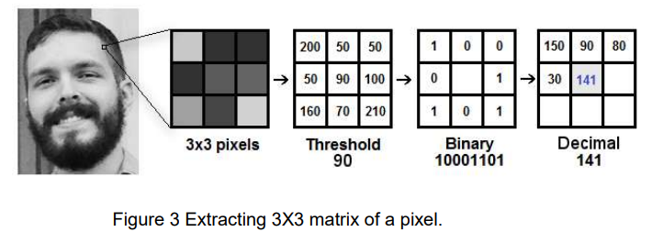In the above formula, ‘n’ is the 8 neighbors of the central pixel, ic, and in are the grey level value of the central pixel and the surrounding pixel, respectively. S(x) is 1 if x is greater than or equal to the threshold. S(x) is 0 if x is less than the threshold.

The calculated decimal value is replaced with the central value. Hence, we obtain the characteristics of the original image in a new image. Once all the processes are complete, a histogram is extracted from each grid and are concatenated. This process is repeated for all the images and a histogram is generated. To compare two images, histograms are compared at a time. The comparison is done by Histogram Intersection. Its formula is given below:

∑j=1 min(Ij,Mj)

Here, j is the bin number and I and M are histogram 1 and histogram 2. If the intersection value is greater than 80% then, the image is successfully recognized.

**7.0 Advantages**

* It’s easy to maintain.
* It’s user-friendly.
* No human intervention is required for marking attendance.
* The system recognises faces and records attendance.

**8.0** **Disadvantages**

* To detect a face, the candidate must be in an area with light; otherwise, it will not be able to detect it.
* Threatens privacy.
* Imposes on personal freedom.
* Violates personal rights.
* Data vulnerabilities.
* Misuse causing fraud and other crimes.
* Technology is still new.
* Errors can implicate innocent people

**9.0 Project Life Cycle**

The waterfall model is a classical model used in the system development life cycle to create a system with a linear and sequential approach. It is termed a waterfall because the model develops systematically from one phase to another in a downward fashion. The waterfall approach does not define the process to go back to the previous phase to handle changes in requirements. The waterfall approach is the earliest approach that was used for software development.

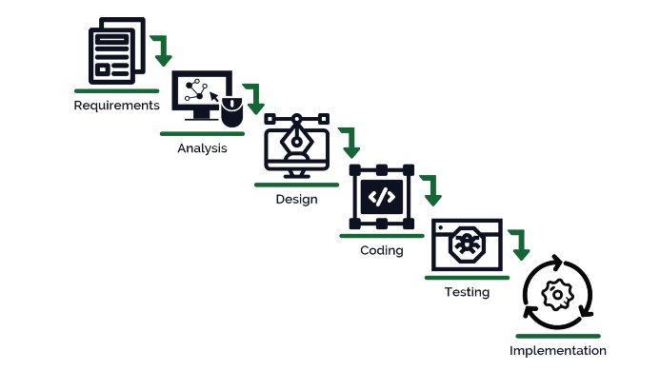

**10.0 System Requirements Specification**

**10.1. Technical Requirement**

**i. Hardware Requirements**

* A standalone computer (13 5th Gen, 8gb ram or higher)
* High-quality wireless camera to capture images
* Secondary memory to store all the images and database

**ii. Software requirements**

* PyCharm professional 2017.2.4 or higher
* Python 3.5 or more
* Windows 8 or higher
* Latest version of all libraries

**10.2. Functional Requirements**

System functional requirement describes activities and services that must provide.

* A user must be able to manage student records.
* An only authorized user must be able to use the system.
* A system must be attached to wireless camera and face recognition should be
* smooth
* The administrator or the person who will be given the access to the system must
* login into the system before using it.
* The information must be entered and managed properly.

**10.3. Non-Functional Requirements**

Non-functional Requirements are characteristics or attributes of the system that can judge its operation. The following points clarify them:

a. Accuracy and Precision: the system should perform its process with accuracy and precision to avoid problems.

b. Flexibility: the system should be easy to modify, any wrong should be correct.

c. Security: the system should be secure and saving student's privacy.

d. Usability: the system should be easy to deal with and simple to understand.

e. Maintainability: the maintenance group should be able to cope up with any

problem when occurs suddenly.

f. Speed and Responsiveness: Execution of operations should be fast.

**Non-Functional Requirements are as follow:**

* The GUI of the system will be user-friendly.
* The data that will be shown to the users will be made sure that it is correct and is available for the time being. The system will be flexible to changes.
* The system will be extended for changes and to the latest technologies.
* Efficiency and effectiveness of the system will be made sure,
* The performance of the system will be made sure.

**11.Application**

* Facial recognition technology is one of the emerging innovative technologies that help companies, organizations, and government agencies to improve their business productivity. It helps in identifying and recognizing people.
* It is an analytical tool that identifies a person by matching their face with the stored image in the database. Then, an algorithm compares a person's facial features against the facial features of the stored images on the database. This technology has gained rapid acceptance globally among global brands.
* It is a fast, high-accuracy system that accurately identifies and recognizes faces for identity verification, customer identification, security, access control, and other uses.
* The technology is used in various sectors, including finance, retail, government, and industry. For instance, it can be used in automated teller machines, retail banking, airport check-in, customer identification, and credit/debit card payments.

**12.** **Project Challenges**

* **Illumination**

Illumination stands for light variations.  The slight change in lighting conditions cause a significant challenge for automated face recognition and can have a significant impact on its results.

* **Pose**

Facial Recognition Systems are highly sensitive to pose variations. The pose of a face varies when the head movement and viewing angle of the person changes.

* **Expressions**

Face is one of the most crucial biometrics as its unique features play a crucial role in providing human identity and emotions. Varying situations cause different moods which result in showing various emotions and eventually change in facial expressions.

**13. Diagram**

**A. Function Diagram**

**Camera**

**Pattern Extraction**

**Image to**

**Grayscale**

**Vision Acquisition**

**Update Attendance Sheet .xlsx**

**Find Match in**

**Database**

**Feature Extraction**

**B.** **Activity diagram**

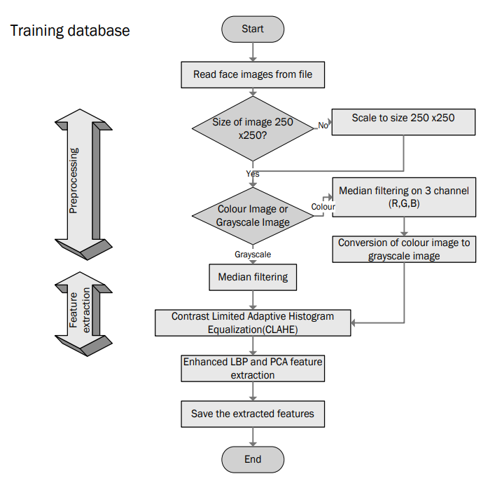

**C. Class Diagram**

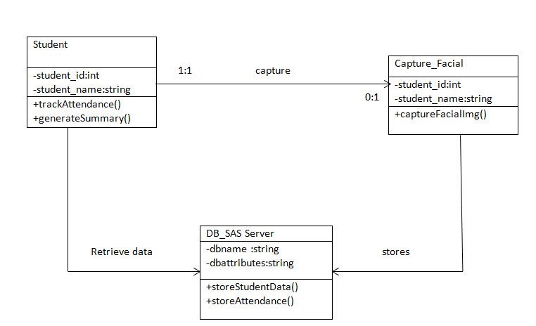

**D. Sequence Diagram**

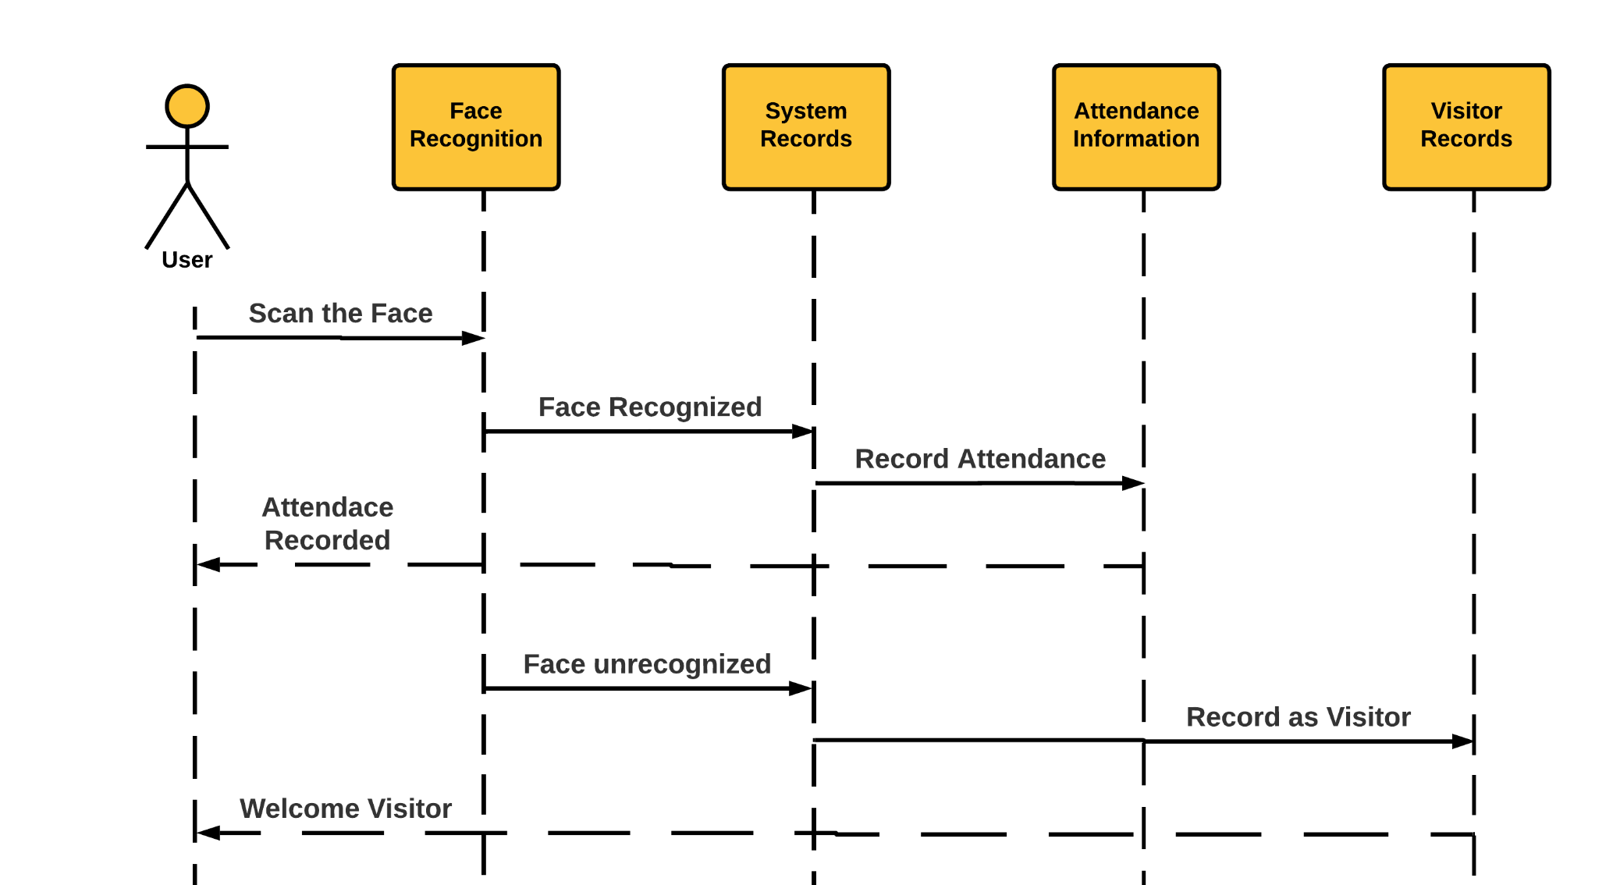

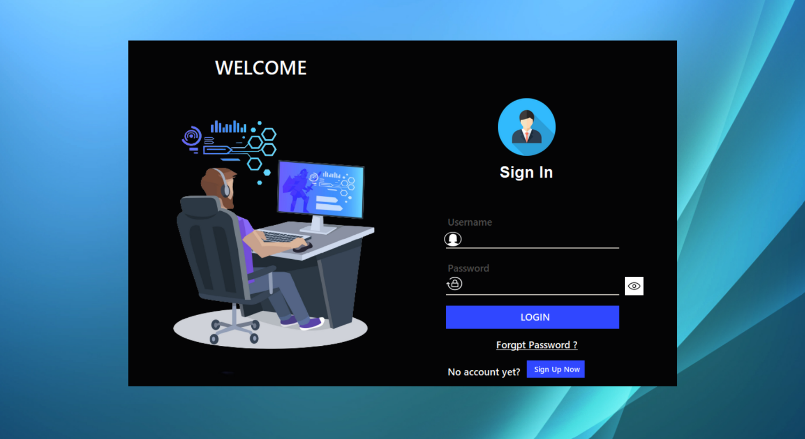**14.** **System Screenshot and Explanation**

Figure 1: Login Page Interface

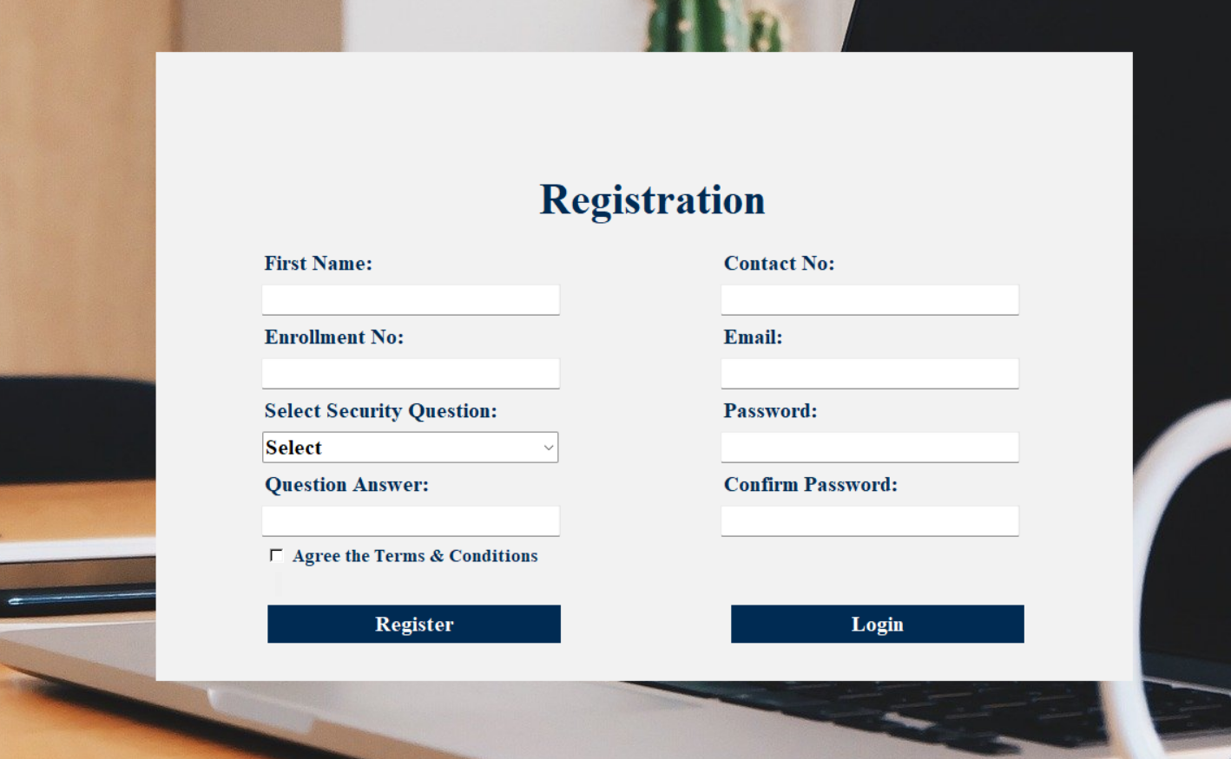 Figure 2: Sign Up Page Interface

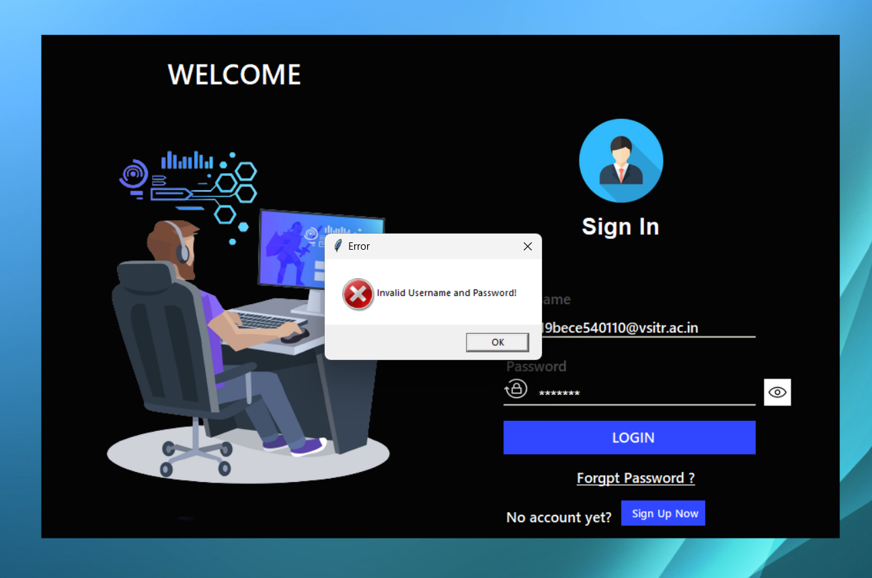

Figure 3: Unsuccessful Login

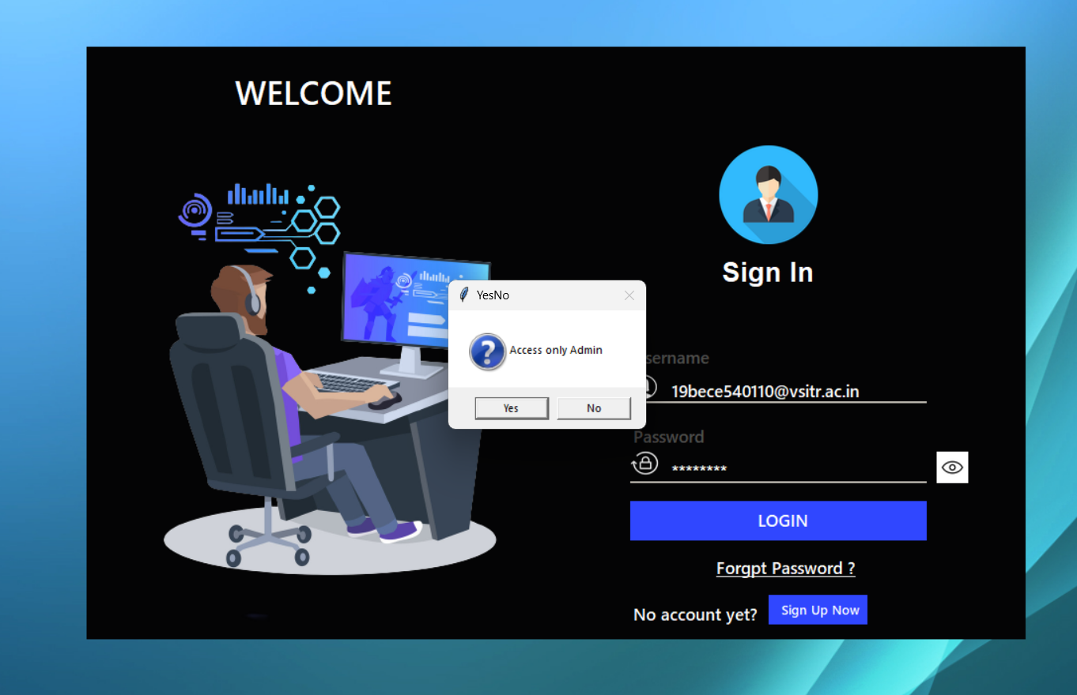

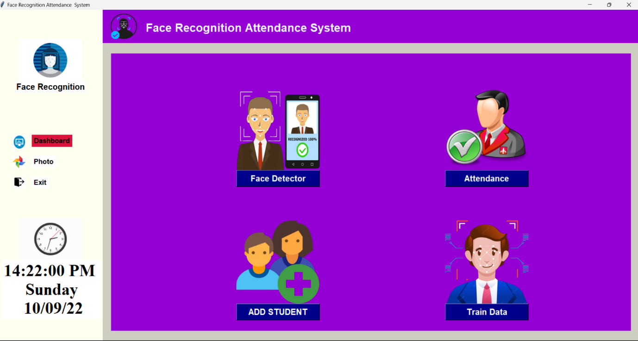Figure 4: successful Login

Figure 5: Dashboard Interface

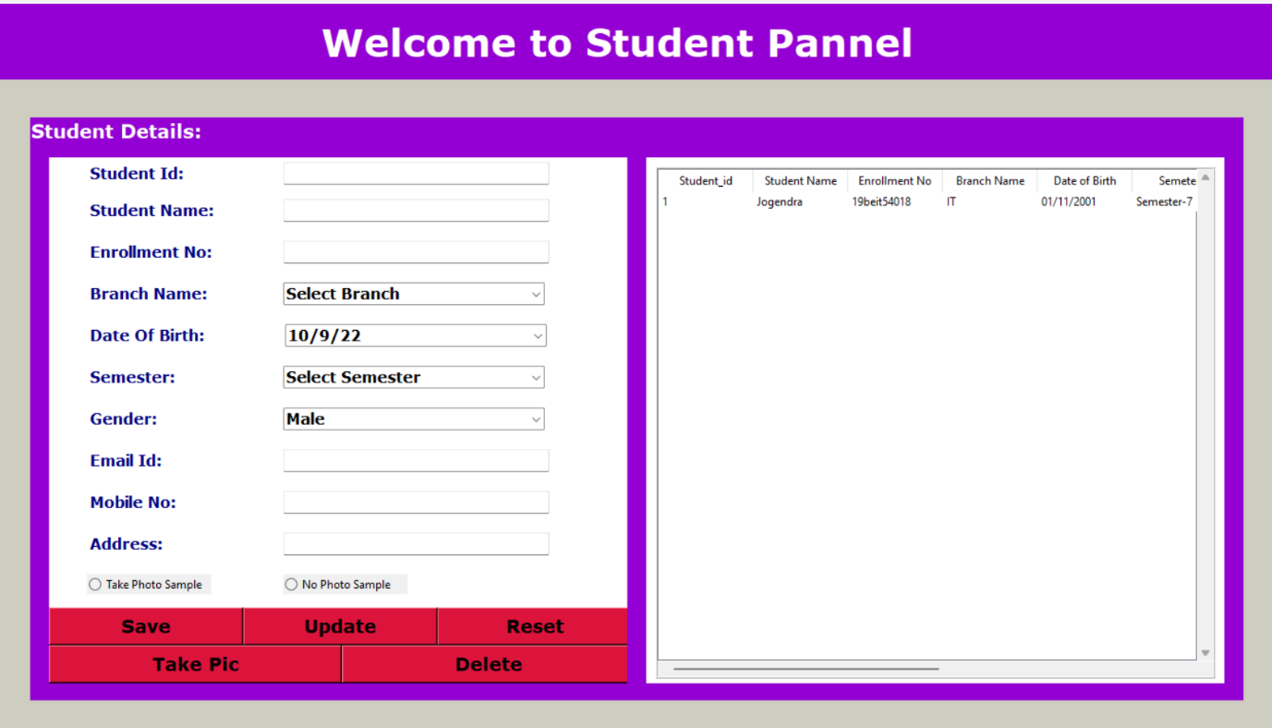

Figure 6: Register Form

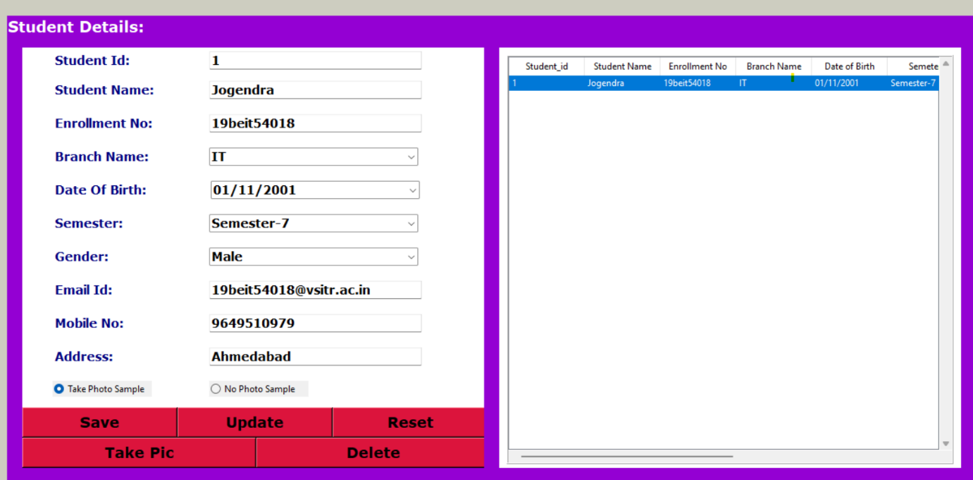

Figure 6: Register Form filled

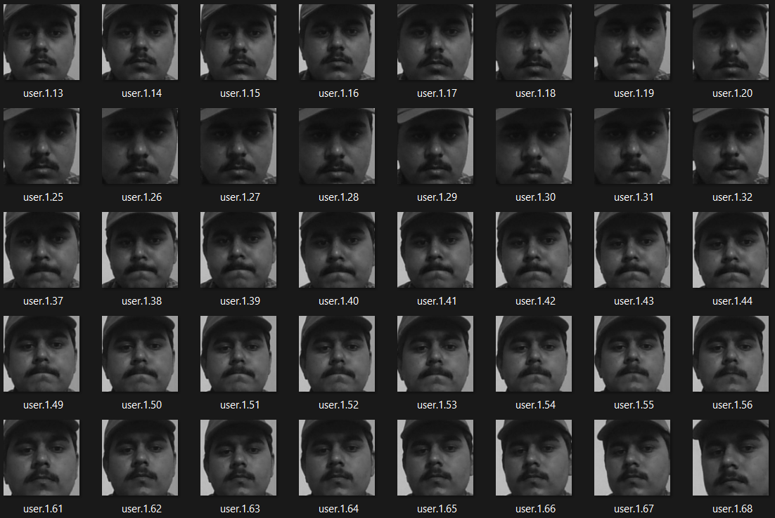

Figure 7: photo database

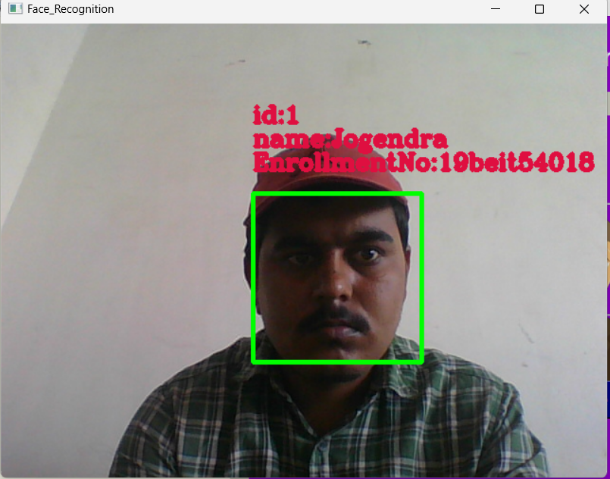

Figure 8: Attendance time

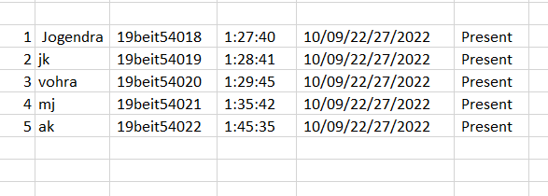

Figure 8: Generate Attendance in Excel fi